**Ski the ultimate in Europe with The Lewisch Ski Group in 2026!**

# February 20-28, 2026

**$4,200.00\*\*** Per Person

*Zermatt-a high ski Mecca for all levels of skier! Best known for its southern exposure, high snowfall levels and quintessential Swiss charm, Zermatt is an incredible ski destination. Ski the three main ski areas of*

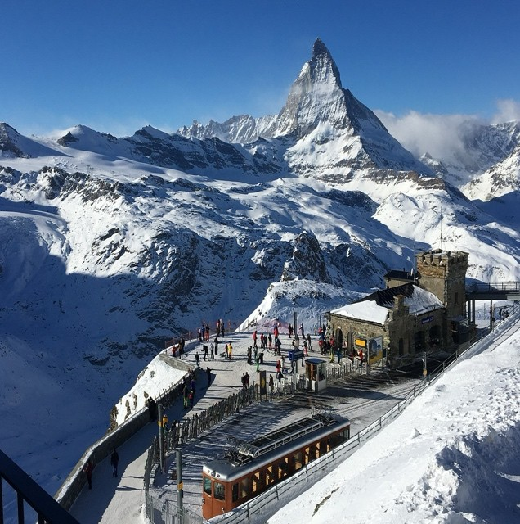

*Tiefbach, Aeroleid or Momatt, and then ski across the border to Cervinia,*

*Italy for lunch! Zermatt is also renowned for it's "all inclusiveness' and no use of cars in the village. Nightlife, entertainment and non-stop skiing-Zermatt has it all!*

*Stay at the fabulous four-star* ***Hotel Albana Real****. Experience luxurious comfort that is within steps to the lifts and easily accessible to the rest of the village. Views of the Matterhorn from the hotel balconies, Gourmet dining (5 nights), indoor pool and sauna, a solarium, and full-service front desk and concierge services make staying at the resort one pleasure after another. You will absolutely love the Albana Real, and it may prove to spoil you for future trips—indulge and enjoy!*

**Trip Price Includes all of the Following**:

* Round-trip air Non-Stop Newark to Zurich on SWISS
* Round-trip Motorcoach and train transfers direct to the village (buses and cars are not allowed in Zermatt!)
* Seven nights’ accommodations at the Four-Star *Hotel Albana Real*
* Welcome Party Upon arrival in hotel in Zermatt
* **Full European Breakfast daily**
* **Five (5) Gourmet dinners at the hotel (two nights dinner will be on your own) explore)**
* All resort taxes, surcharges and fees*

*(**Does not include Int’l Dep taxes—currently appx. $550.00*)

**Price:**  **$ 4,200.00** per person** **(double occupancy)

**To sign up or obtain additional information please contact: glewisch@geritlewisch.com Initial deposit of $ 1,000.00per person due ASAP to confirm your spot on this popular trip**

**Please make checks payable to Gerit Lewisch and mail to  6001 Point Pleasant Pike, Doylestown PA 18902**

*(Cut here)*

**Enclosed is my (our) $ 1000.00 per person deposit(s) for the Zermatt Trip Feb. 20-28, 2026**

Name(s): Rooming with:

(**EXACTLY** as it appears on your Passport) Email 1: Email 2: Main Phone 1: Passport # & Exp date: DOB:

Main Phone 2: Passport # & Exp date: DOB:

Address 1: Address 2:

TSA/GLBE 1: TSA/GLBE 2:

**Yes, I have read and understand the cancellation & refund policies on the reverse side.**

**Signature______________________Date________________Signature_____________________ Date____________** RESPONSIBILITY CLAUSE

ALPHORN TOURS & INCENTIVES, INC. and or its agents, act in the capacity of agent for the passengers in all matters pertaining to travel, whether by plane, rail, boat, steamer, or any other means of conveyance. They shall not be liable for any injury, damage, or loss occasioned by neglect or default of any company or person engaged in conveying the tour, or any hotel proprietor or car rental organization or other persons supplying services or materials in connection with the tour. Neither ALPHORN TOURS & INCENTIVES, INC., (and or its agents) nor the airline concerned are to be held responsible for closure of access routes to or from resorts due to bad weather or road conditions, or for any other reasons beyond their control. In addition, they are not to be held liable for any additional payment or any refunds for unused hotel accommodations or meals occasioned by such late arrivals at hotels holding rooms as per confirmed itineraries or any other hotel. ALPHORN TOURS & INCENTIVES, INC., and its agents act only as agents for reservations concerning hotels, transportation and sightseeing tours (if included) and do not guarantee the psychological satisfaction of the client for these reservations. Neither the tour operator nor its agents assume any responsibility or liability for schedule and time changes of airline, transfer companies and trains.

|  |
| --- |
| DEPOSIT / PAYMENT REQUIREMENTS:  **$1,000.00 deposit per person due ASAP to hold space**  **2nd payment of $1,600.00 per person due Sep. 19, 2025;**  **Final balance per person due on or before Dec. 10, 2025** Sorry Credit Cards cannot be accepted.  **\*\*\*LIMITED Single supplement of $1,495.00 are available and if requested, may apply if suitable roommate is not Available\*\*\*\***  Cancellation penalties will apply after OCT 20. *Attempts will be made to provide a suitable roommate, but if one is not found, or if your cancellation leaves your roommate single, a supplement may be incurred. |

## CHANGE OF ITINERARY

**Any changes in the itinerary will result in a $150 change fee, plus any additional charges as a result of the change--if the change is possible**. There will be no refunds for any unused portions of the trip as the group rates are based on everyone following the same itinerary.

## CANCELLATION & REFUND POLICY

Some restrictions and penalties apply to your vacation investment. If you cancel your reservations, YOUR RIGHT TO A REFUND IS LIMITED, as set forth in the following schedule. All cancellations **must be in writing and sent** **to Alphorn Tours, Inc**., 1 Harris St.

Newburyport, MA 01950. Date of postmark will determine applicable policy:

***After September 1, 2025 and up to 120 days (October 20, 2025) prior to departure cancellation policy is as follows:***

**A:** Any and all cancellations are subject to a $250.00 per person contracted administration fee up until 120 days prior to departure.

**B:** Any and all cancellations received 119 to 90 days prior to departure - $1,000.00 per person contacted cancellation fee.

**C:** Any and all cancellations received 89 to 45 days prior to departure - $ 2,500.00 per person contacted cancellation fee. **D:**  Any and all cancellations received 44 days or less to departure – **no refunds**.

No refunds for early departure or late arrival. No shows, no refund. No partial refunds will be made on car rentals, airfare, or unused portions of this package. **Refunds will be made as soon as they are received from vendors (minimum eight (8) weeks).**

## INSURANCE

We strongly recommend the purchase of trip insurance covering, accident, sickness or death of a participant or covered family member that would result in cancellation either prior to or during the trip.

Trip participants can go to www.alphorntours.com homepage and click on the Travel Insured link to sign up for trip insurance. If calling Travel Guard (800-549-9037) give Alphorn Tours agent code of 125081 to sign up.

## PASSPORT

**For Passport Info go to** http://travel.state.gov/passport**; Valid 6-months** after return date required!!!

